ISSACK WAITHAKA
cs-sa07-24085

I started by starting the machine
initial access
- I connected to the machine via ssh
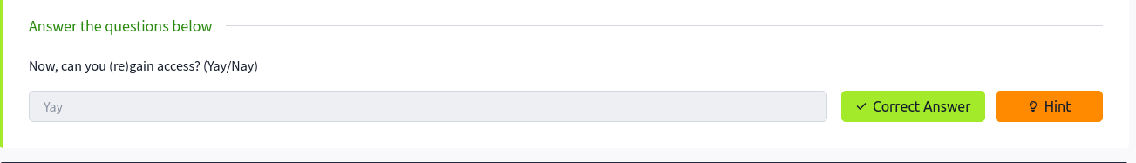
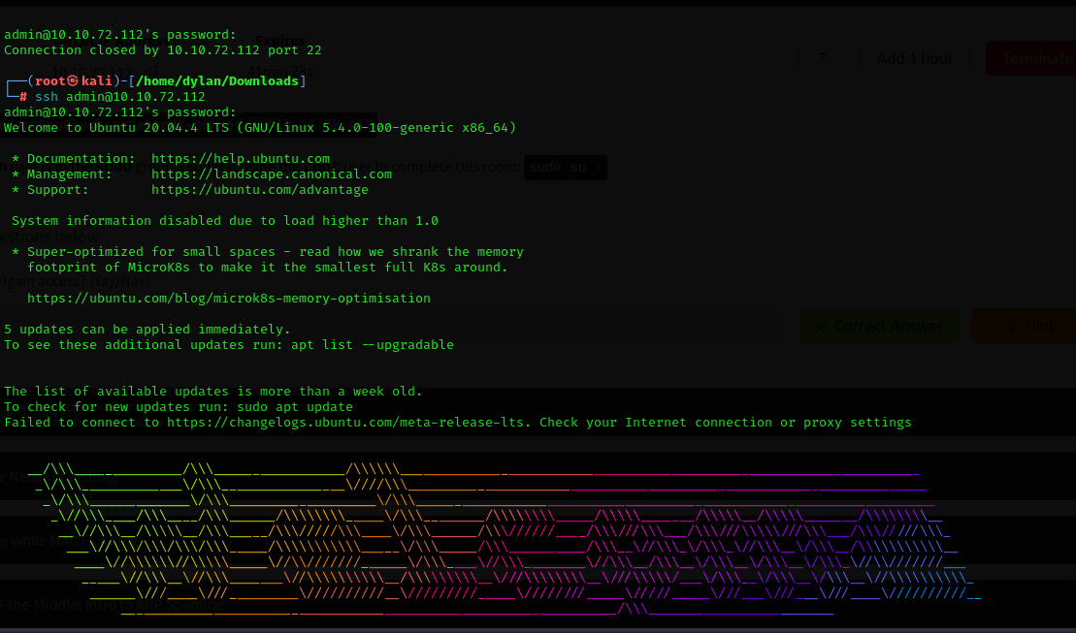
Network discovery
Questions
1.
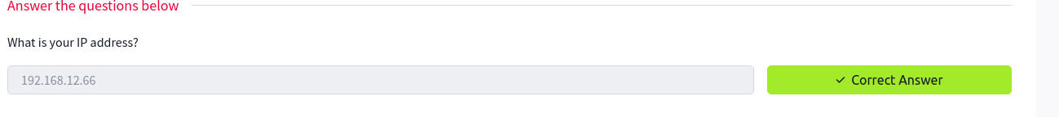
2.
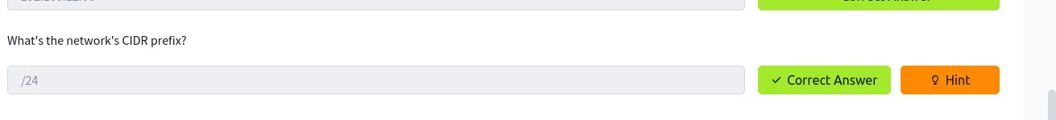
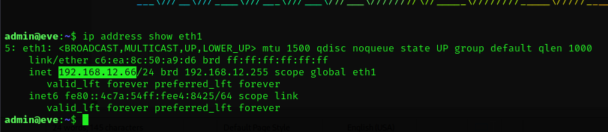
3.
Questions
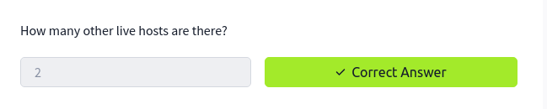
We do not do not include Eve because we are using her access
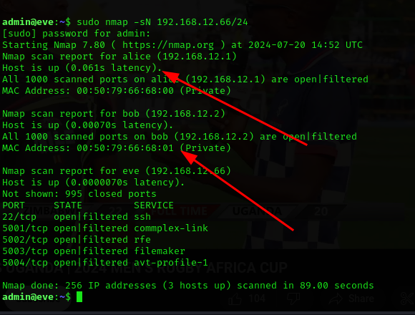

5.


Passive Network Sniffing
- I used this command tcpdump -A -i eth1 -w /tmp/tcpdump.pcap to capture traffic and save them in tcpdump.pcap file

Questions
1.

2.
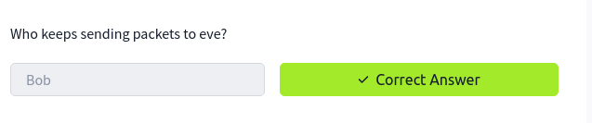
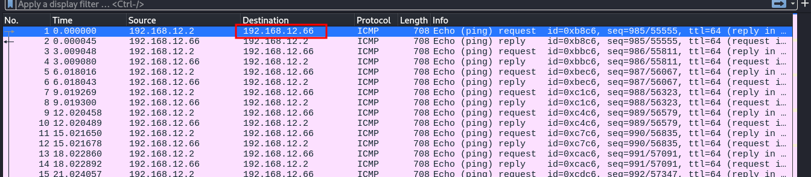
From the nmap result we noted that the IP sending Eve the requests was Bob’s
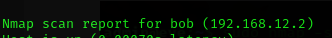

I copied the file to my local machine
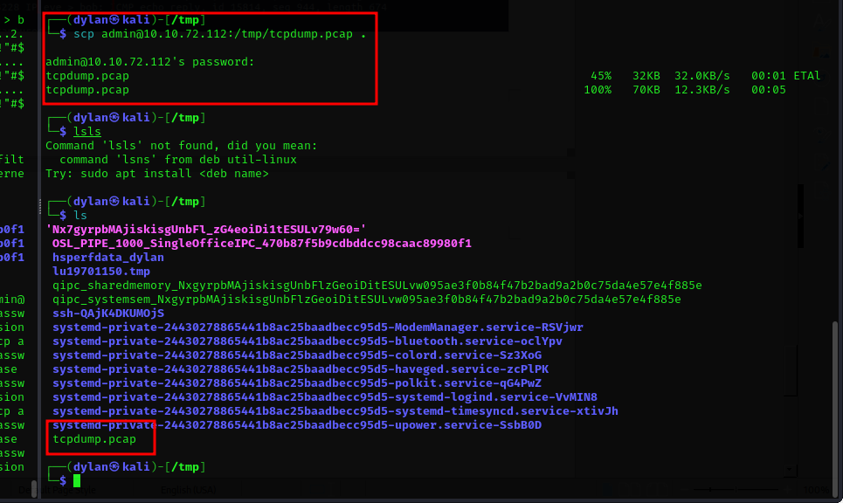
and opened wireshark
3.
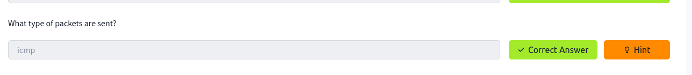
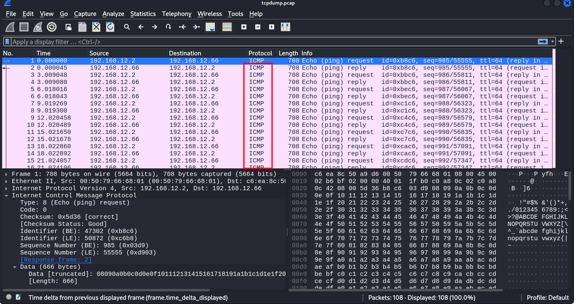

4.

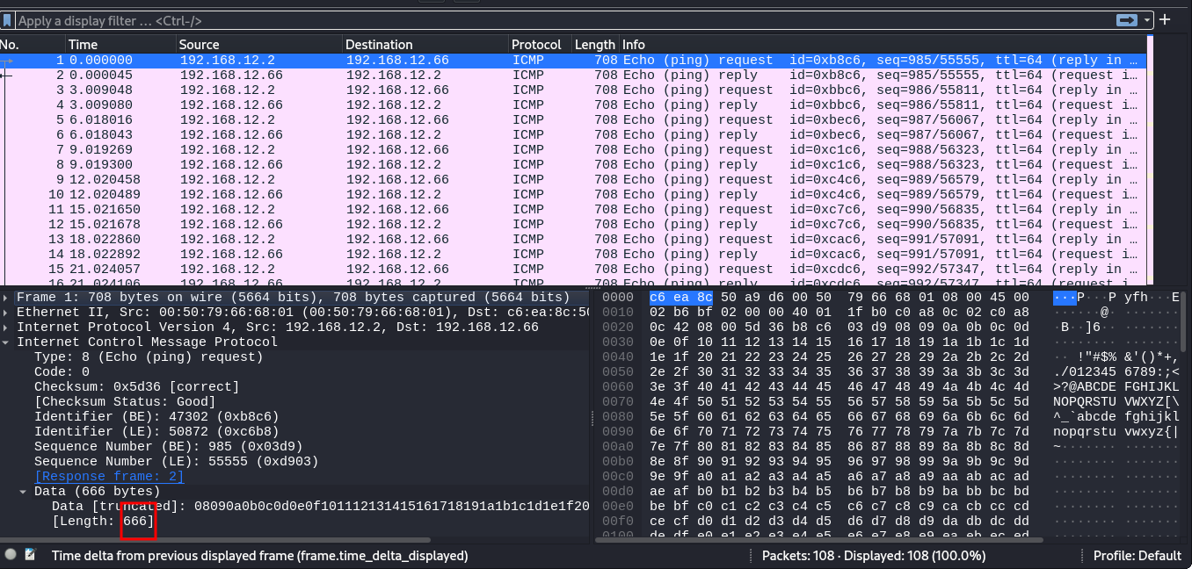

Sniffing while MAC Flooding
- We can try to launch a mac flooding against the machine.
- I opened a new ssh session so as to leave the tcp dump process running
- On the new ssh I started macof to run against the flooding switch
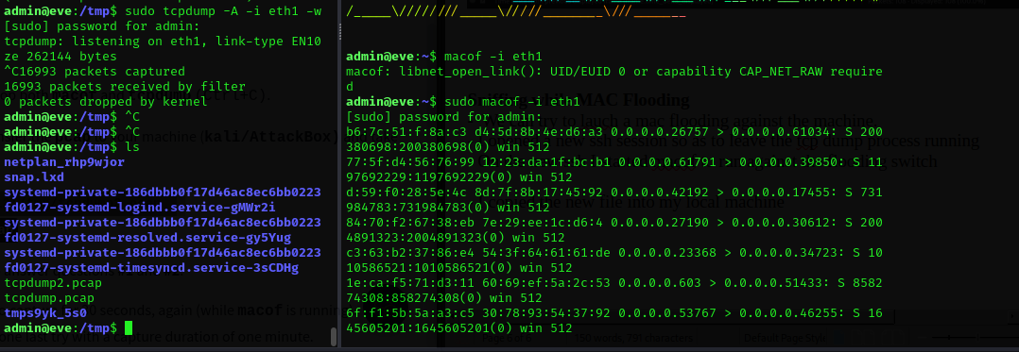
- I copied the new file into my local machine and started wireshark
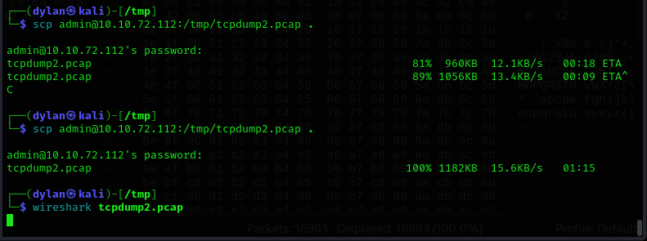
Questions
1.
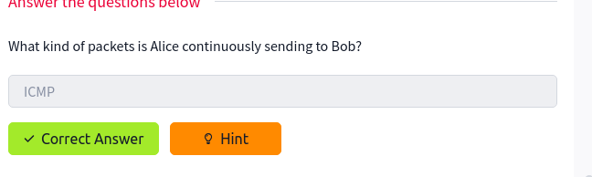

2.

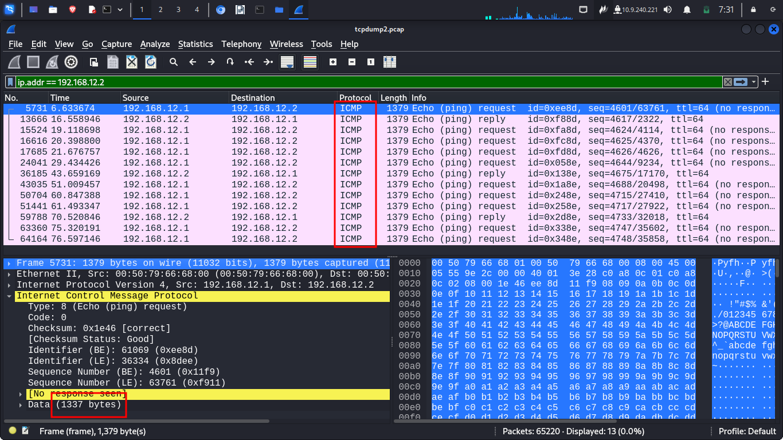

Man-in-the-middle:Intro to ARP spoofing
- We are going to ru arp cache spoofing attacks because the mac flooding is a bit noisy
Questions

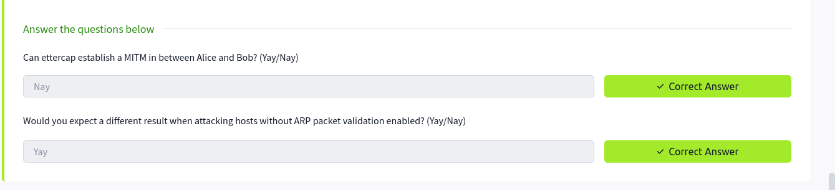

Man-in-the-middle: Sniffing
Questions
1
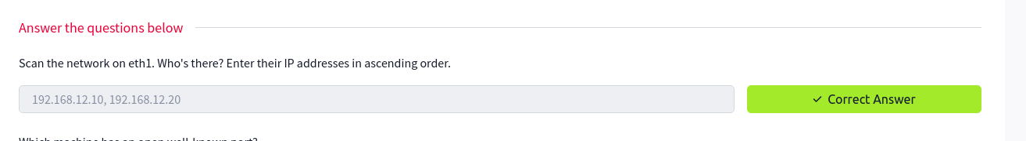

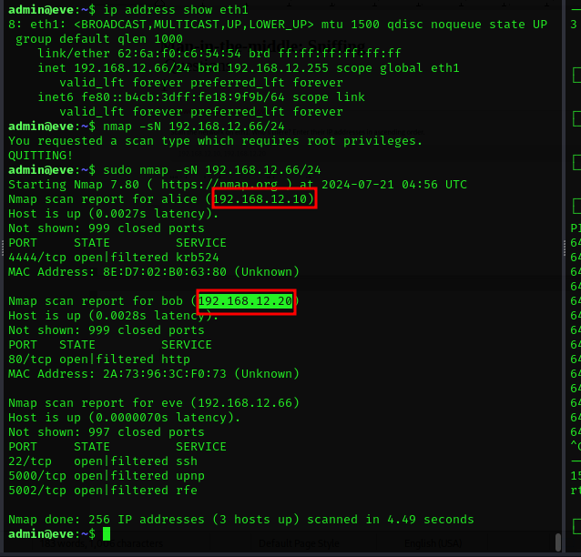
2.
3.

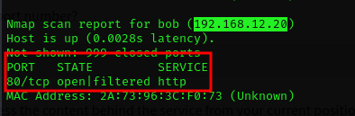

4,5.
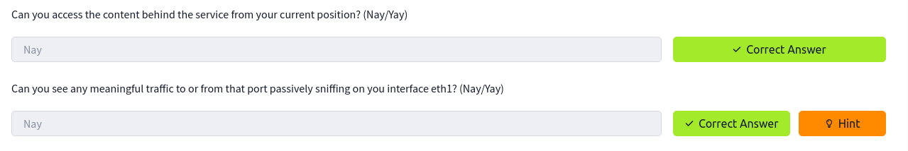
6.
7.
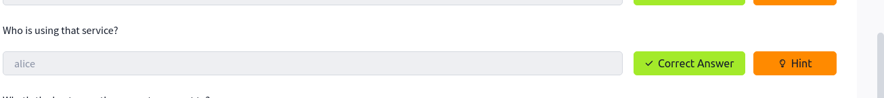
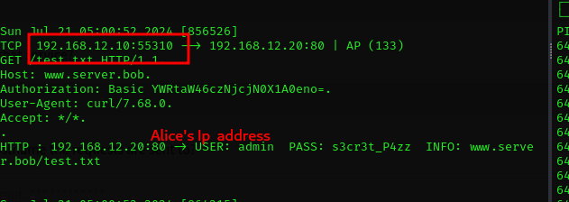
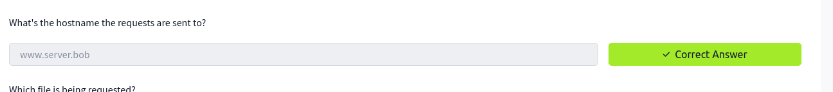
8.

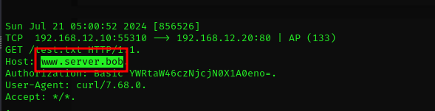

9.
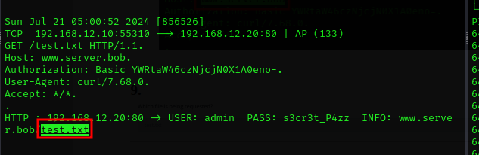
10.
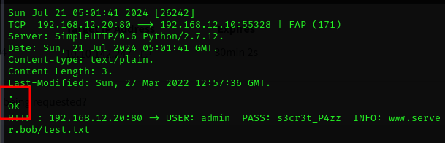

11.
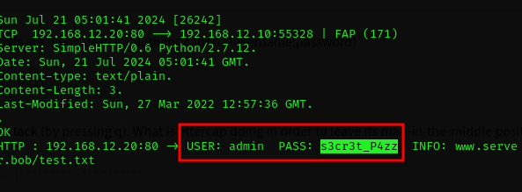
12.
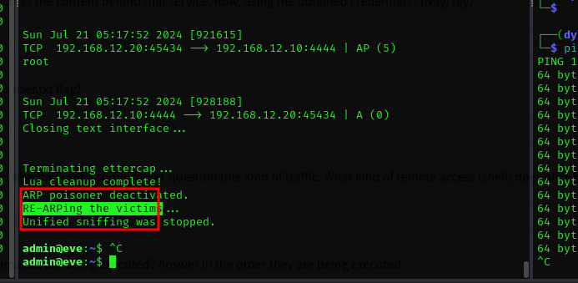
13.

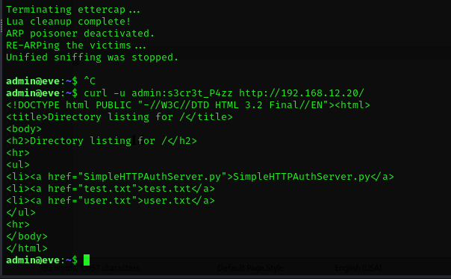
14.
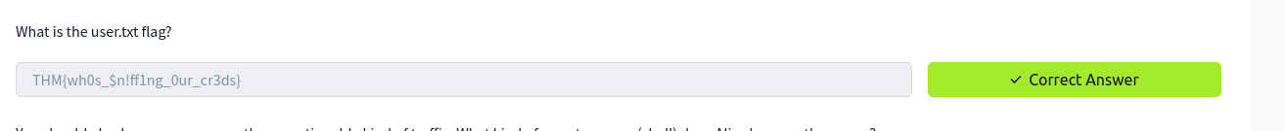
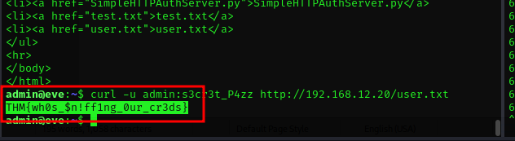
15.

It is a type type of connection you want to catch when compromising hosts allowing you to execute commands by calling back to your listener.

16.
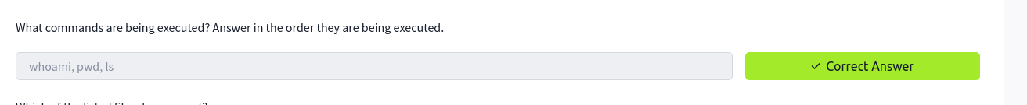
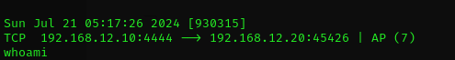

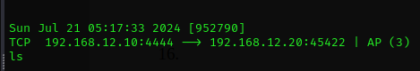

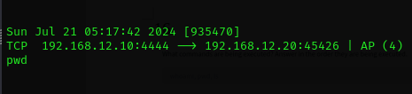

17.
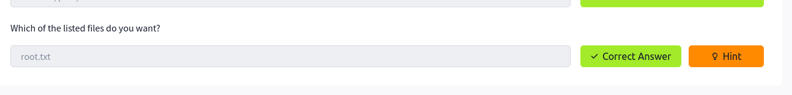
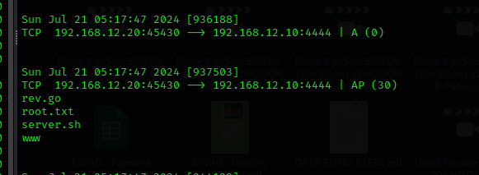

Man-in-the-middle manipulation
- We can tamper with Alice packets as pass through Eves machine
- We are going to be using etterfilter which is a filtering compiler for ettercap

Questions
1.
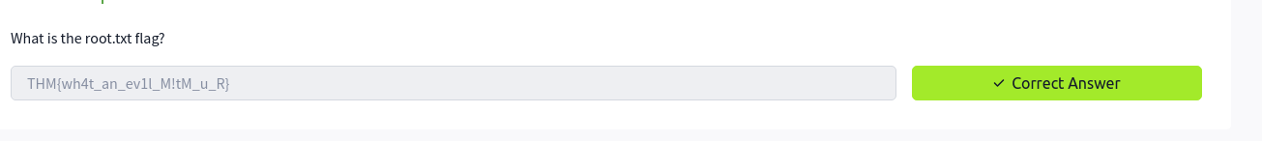
- To get to this The first step was to create an etterfilter file ‘whoami.ecf’and try to write Alice’s ports and replacing whoami data with a reverse shell.
- Next step was to compile the .ecf Into an .ef file

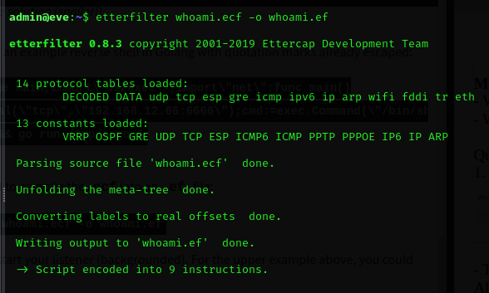
- Next we start a listener and run the ettercap specifying my newly created etterfiter file
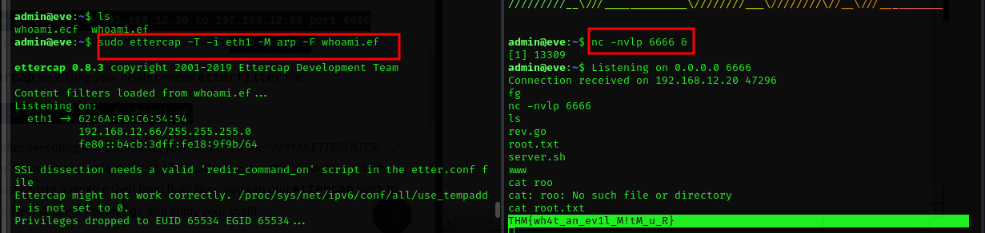
- And that is how I got the shell

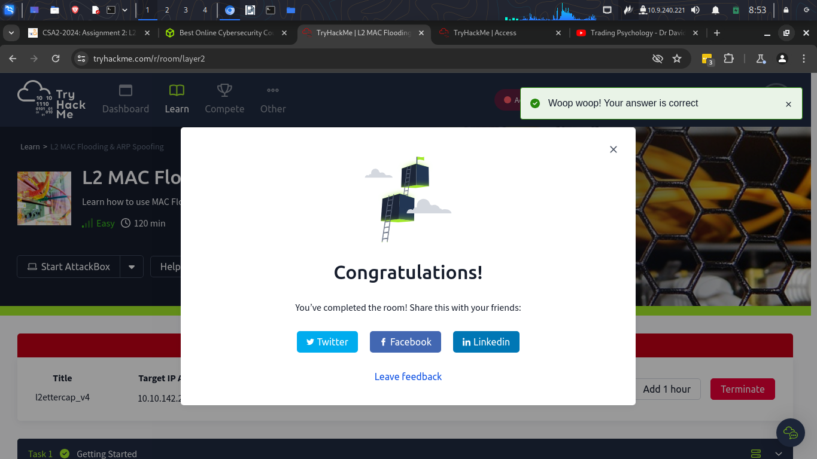

Conclusion
- In this room I have learnt about network pentesting. I have also learn how a man in the middle attack can be fatal when it comes to networking. I have learn how to poison an arp request and mac flooding which are important skills needed in y this field. With the skills acquired I can say that I am comfortable with mac flooding and arp spoofing.

